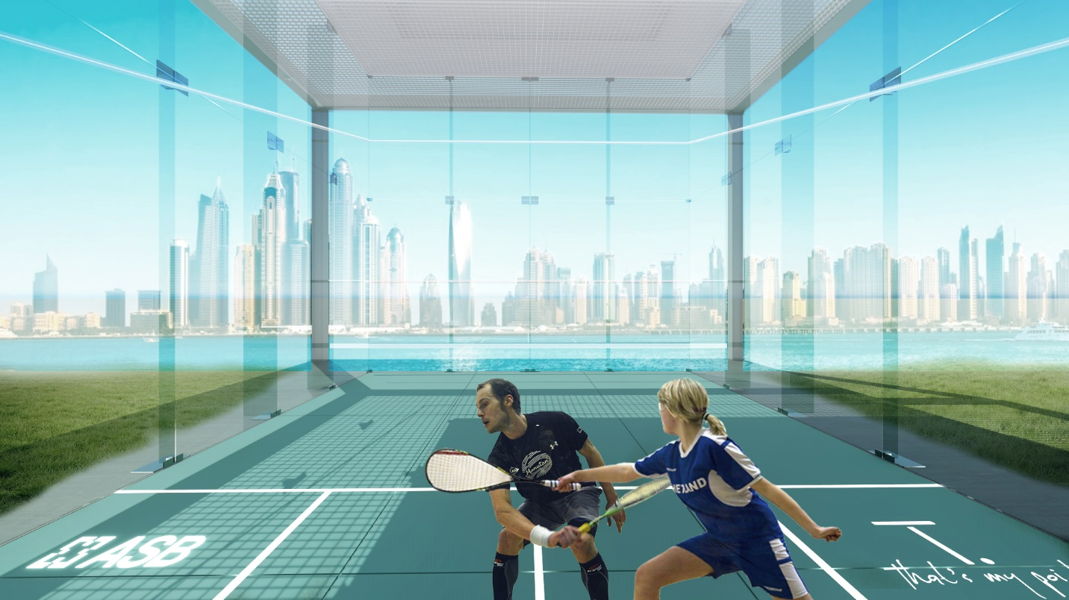

What makes a tough sweaty game -
Simply sophisticated, updated and desirable for everyone?

The pure and simple transparent functionality concept that is turning squash from a limited indoor game to a dynamic outdoor success.
Our beautifully designed smart courts, with innovative technology, will create a new and exciting sport experience.” Says Yossi Fixman, inventor of TPoint, who has joined forces with ASB, the world’s leading squash court manufacturer, in a major new initiative to ‘take squash to the people’. Together they are literally creating a “game-changer” by bringing squash from ‘hidden’ areas to visible outdoor areas; Parks, hotels, universities, private homes, office and residential roof tops around the city”.
The first smart outdoor squash courts are based on the concept- form meets function. “Very fast it occurred that the design should be simple and yet modular, kind of design that can fit anywhere and to anyone”. Explains Erez Lukatz, the architecture.

Innovative and creative thinking of how to embed the latest technology into a timeless sport game, has brought to life bold ideas for everyone to enjoy. The transparent glass cube is based on the outstanding ASB Glass Walls which are familiar from the major international tournaments, featuring the world`s leading players. The Glass Floor is the most advanced flooring system in the world; anti-slip, no reflection, the surface is made of tempered safety glass. Each panel is made of two sheets of safety glass, held together by a 1.52mm PVB safety foil. The floor consists of 12 panels and has LED marking lines which can be switched on and off as required. Any logos, patterns or advertising can be imprinted at the same time. And to complete the minimalistic look: TPoints’ flying roof is a Light metal structure stretches further over the court providing extra sun protection for players, and shading for spectators. For those who prefer some privacy, TPoint has planned
Electronic shades which also supply sun protection, these can be customized from the control system.
The Glass door starts the entire activation of the smart court. Once the door is opened: customized lighting, air-condition, audio and video systems are turned on and the adrenalin starts running!
Technology takes a major part of the TPoint’s concept. The idea was to plan and to design an easy way to use the court, so we have developed a smart system which allows the players to entrance the court. Then, once they are recognized, the players may customize the court features: Color of the LED marking lines on the wall and floor, A/C, audio, video, electronic shades and timer display. The players will connect to the TPOINT website for syncing their information: court reservation, final bill, score date, and more.
The smart system which is developed to support the court operating will be part of an app TPoint will launch. The app will expand its utilities for players in order for them to schedule games, challenge other players, share on social media, track scores and more.
TPOINT is much more than just a squash court, It`s a social hub."Building any squash center means a significant investment. Normally the investment is focused on providing the building and infrastructure around the courts and a maximum of 15% is actually spent on the equipment (squash courts). However, the squash court is what matters the most to the actual end user, the player. TPoint addresses this issue in a beautiful way where most resources are spent on the playing surfaces with the superb side effect of creating this impressive urban space and social hub.” explained ASB CEO Christof Babinsky.
TPOINT requires 100 SQM for a single court to 1500 SQM for 6 courts including social and service areas. “During the design process, we studied and worked the courts composition, the structure, the proportions of the building, the impact of different combinations and modularity, the relationship between the glass volumes and the public space”, says Lukatz.
The best part about the TPoint design is that while it is meant to house the game of squash, it is the ideal outdoor addition to any hotel, home, business, or establishment because of its unrivaled versatility. The structure can house cocktail parties, yoga classes, business meetings, and so much more.

Squash is the world’s healthiest sport, played in over 175 countries by over 20 million people and is very easy to learn. Anyone can learn how to play. Squash is a powerful, tough, competitive, fun sport. "The innovation ASB is driving with TPoint meets a need in the US which is increasing access to squash. TPoint also addresses the challenge we have in raising awareness of the sport, so presenting squash in a visually appealing way, in an outdoor setting, is ideal”, explains Kevin Klipstein, the President and CEO of US Squash. "TPoint solution really could potentially dramatically accelerate our recent growth in the US, especially in the warmer parts of the country."

ASB has never limited themselves to simply building squash courts.
Furthermore, “We are bringing to the world a completely modular activity Center with the highest quality”. Says Fixman, the entrepreneur, “TPoint Club in public areas will provide a total experience; food and bar, social areas pro shop, therapy room, restrooms and lockers area. TPoint is a revolutionary center solution, Creating a unique atmosphere before, during and after the games.”

Enthusiasm is all over; Gregory Gaultier, the reigning World Champion, is also highly impressed with the pioneering innovation. “I can’t wait to try it myself,” said the Frenchman.

TPoint- Area on the court where the short line intersects with the half court line. The best location for a player, to control and overview the opponent and the match.
And now it is also the world’s first smart outdoor squash courts.
Let’s start the game, and let’s play like everybody is watching! Tpoint, that's my point!

